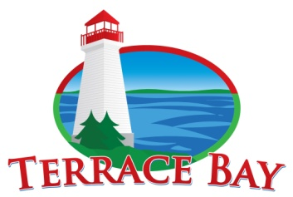
The Corporation of the
Township of Terrace Bay
P.O. Box 40, 1 Selkirk Avenue, Terrace Bay, ON, P0T 2W0
Phone: (807) 825-3315 Fax: (807) 825-9576

ATTENTION
TOWNSHIP WIDE BOIL WATER ADVISORY

Monday May 15, 2023, 5:30 PM

All Residents and Businesses Affected

Effective immediately Monday May 15, 2023, 5:30 PM until further notification, the Township of Terrace Bay will be under a boil water advisory.

The Boil Water advisory will be lifted as soon as results ensuring water quality are received.

Information regarding what to do during a "Boil Water Advisory" is available at the Municipal Office (807) 825-3315 or the Thunder Bay District Health Unit at (807) 625-5900.

Please contact the Municipal Office for further information if required.
We sincerely apologize for the inconvenience.

THE CORPORATION OF
THE TOWNSHIP OF TERRACE BAY

J. Hall
CAO/Clerk

